# WEEK 3 QUIZ - Relationships between numeric variables

## Question 1

Parte superior do formulário

**Fill in the missing words. Choose from: outlier, scatter, trend, clusters.**

When we have a trend in our scatter plot, the **scatter** around the  **trend** tells us how strong a relationship is.

**Correct**

Parte inferior do formulário

## Question 2

Parte superior do formulário

**When we do a scatterplot of two numeric variables, ……**

**Select all the answers you think are correct.**

**….. the outcome variable is put on the vertical axis.**

**….. the predictor variable is put on the horizontal axis.**

**….. observations that are unusually far from the trend are called outliers and should be checked to determine if they are real values or mistakes.**

**….. if we see clusters of points, this suggests that there may be different groups of individuals present (e.g. males and females).**

…. if there is a relationship between the predictor and outcome variables, the trend in the scatterplot will always be a straight line.

Correct

Parte superior do formulário

The first statement is **TRUE**. The variable we are trying to explain the behaviour of is always put on the vertical axis.

The second statement is **TRUE**. The variable we use to explain the behaviour of the outcome variable is always put on the horizontal axis.

The third statement is **TRUE**. Outliers can be unusual observations or they can be mistakes.

The fourth statement is **TRUE**. If different groups tend to have different values for the outcome and/or predictor variables, clusters can be seen in the scatterplot.

**The fifith statement is FALSE the trend in the scatterplot can be curved!!**

## Question 3

Parte superior do formulário

**The following statements refer to the scatterplot which shows the relationship between the average life expectancy (ALE) in years, of people in various countries around the world, and the average number of children per woman for each of those countries in 2008.**

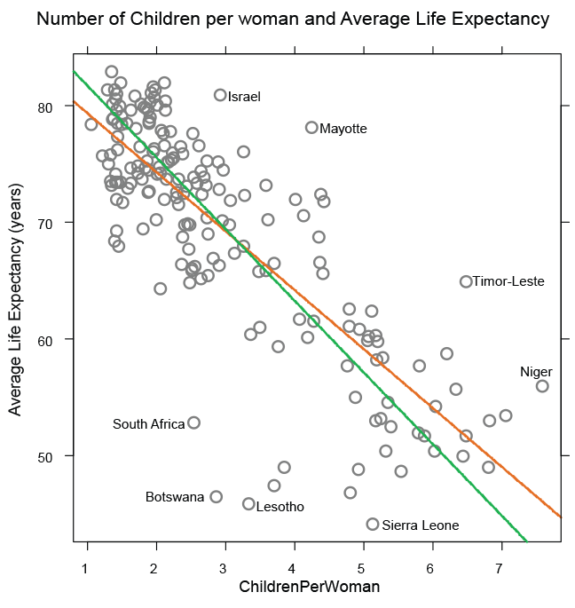

One of the statements is false. Select the **FALSE** statement.

The plot shows a negative relationship between the number of children per woman and the Average Life Expectancy.

If a country that had an average of 3 children per woman had mistakenly been left off the plot, the trend would predict an ALE of about 70 years.

**The better trend line is the green one.**

The ALEs for South Africa and Botswana are much lower than other countries that have an average children per woman of 3 or lower.

**Correct**

This statement is **FALSE** – For each value of number of children per woman it is the orange trend line that goes approximately through the centre of the data. (The orange line is the one that is lower at the left, higher at the right.)

Parte inferior do formulário

## Question 4

Parte superior do formulário

The following statements refer to the following scatterplot of residential electricity use per person and CO2 emissions per person.

**CO2 Emissions** (units: tonnes per person per year)  
**Residential electricity use** (units: KWh per person per year)

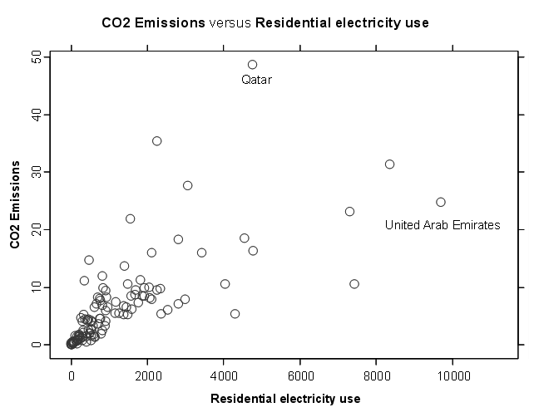

One of the statements regarding the relationship between CO2 emissions and residential electricity use is false. Select the **FALSE** statement.

**CO2 emissions** is being treated as the outcome variable and **Residential electricity use** as the predictor variable.

**United Arab Emirates is an outlier because it is a quite different to the rest of the data.**

If a country had a residential electricity use of 1000 Kwh/person-year, we would expect their CO2 emissions to be between about 5 and 15 tonnes/person-year.

An increase in residential electricity use is associated with an increase in variability of the level of CO2 emissions.

Very low residential electricity use is linked to very low levels of CO2 emissions.

**Correct**

This statement is **FALSE** – United Arab Emirates is not an outlier as it is within the general envelope of points scattered around the trend line.

Parte inferior do formulário